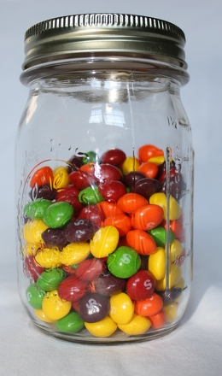
Estimation Jars
An estimate is not just a random guess; it requires thought and reasoning. What better way to practice estimation than with a game? Help your child fine tune their critical thinking skills in relation to volume and size with this simple activity!

What You Need:
- A medium-sized clear jar with lid
- Pennies, sweets, grapes, seeds, paperclips, buttons, nuts, or anything else that can be easily counted
- Pencil
- Paper

What You Do:
- Fill the jar with the items of your choice, but don’t mix items. For example, if you use grapes, don’t put anything other than grapes inside the jar.
- Ask your child to say (& write down) an estimate. For the first estimation, just let them guess without much guidance from you.
- Count out the items with your child and compare the actual amount to the estimated amount.
- Refill the jar either with a different amount of the same item or with new items.
- Make a new estimate together, using what was learned from the first try. For example, if you used grapes but you put in fewer grapes the second time, discuss what that means with your child. (You know it will be less than the first actual amount.) Also, show them how you can count the grapes you see from the outside and make a guess based on that number.
The more frequently you do this activity the better your child will be at estimating, a skill that is essential in mathematics. To make it more interesting, try it with different items, amounts, and jars. You could also offer the items in the jar as a prize for an accurate estimation!

