How Many?
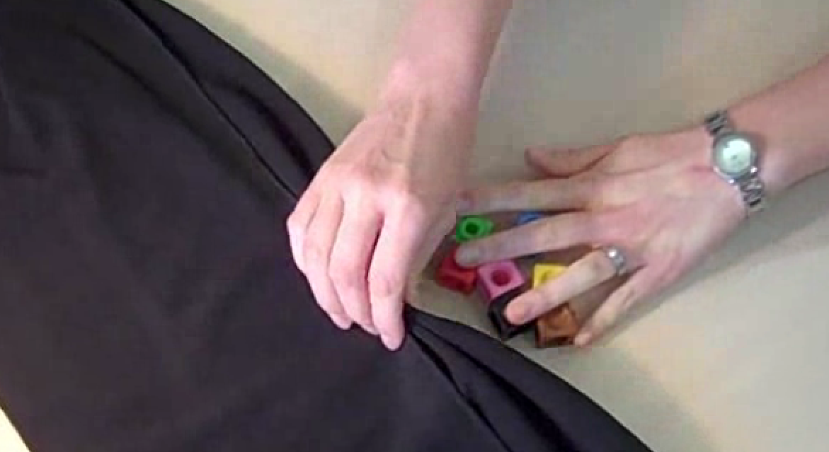
Cover up a small number of cubes [or any kind of object] with a cloth.

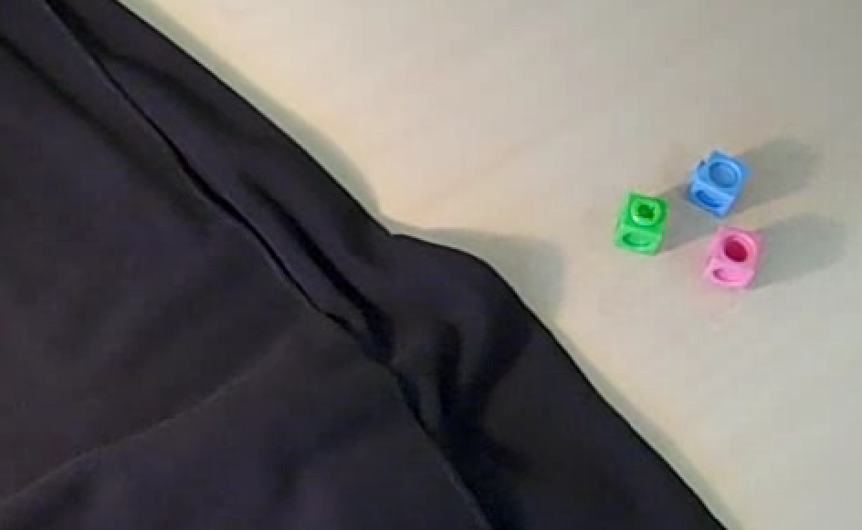
Ask your child to take some of the cubes out from under the cloth and then suggest how many they think are still covered. Take the cloth away to check their suggestion

*You can make the task easier by allowing them to remove one or two more cubes, or to feel the cubes still hidden.

You can extend this game in various ways:
- "I'm covering up 15 cubes. How many would I have to take out for there to be 8 left under the cloth?"
- Give your child some cubes from under the cover, telling them how many are still hidden and ask "How many did I have to start with?"
- Start with a known number of cubes and put them under the cloth. Ask your child to close their eyes while you add a few more cubes. Ask child to remove cloth and count up the cubes – “what was the ‘secret number’ I added?”
Encourage your child to talk about their thinking e.g.
Why do you think there are four hidden?
Tell me about that (thought).
How can we find out?
What questions would you like to ask?
Encourage your child to record what they think/what they find out e.g. using pens & a whiteboard

